Open Repositories: Poster Presentations (Minute Madness)

What is arts research data?
What does it mean to you?
Research, art, design, architecture
I’m going to tell you

What is arts research data?
We tried to find out
We asked various researchers
And this is what we found

What is arts research data?
It’s complex and hard to define
Sketchbooks, paintings, data, drawings
Dependent on your state of mind

What is arts research data?
I have to conclude
It varies amongst researchers
And simply is your… “STUFF”!

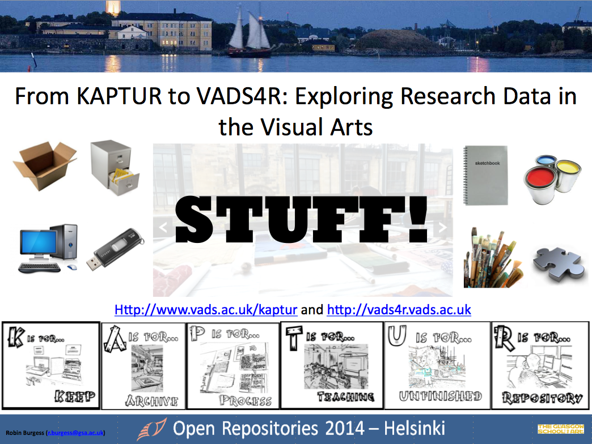

By Robin Burgess (June 2014)

