Enhancing the interface of the research repository at The Glasgow School of Art, through the development of RADAR (Research art design architecture Repository)

The Glasgow School of Art (GSA) were part of a JISC funded project that was looking at improving the take-up and embedding of institutional repositories.

This project aimed to make significant improvements to the user interface and aesthetics of the GSAs research repository. The purpose of this was to help address the challenges in embedding the system within GSA and encouraging take-up among research staff. By addressing these challenges it was our intention to achieve a greater user experience for those using the repository, that the system was easy to use and somewhat enjoyable.

It can be stated that a new repository has been developed and embedded at GSA. The new repository is named RADAR (Research art design architecture Repository). It was developed through the help and input of EPrints (see figure 1).

Prior to this the repository was housed within a Filemaker database. This database was good at storing the required metadata about research outputs but it lacked in interoperability and had a poor user interface. This instigated our involvement with EPrints. Through research into different repository software we decided to embark on the development of an EPrints based repository. Much of this reasoning came about from GSAs involvement in the Kultivate project run by The Visual Arts Data Service in London, who have been engaged with EPrints in developing the software for arts institutes. EPrints is also seen as a common platform for other arts institutional repository – such as The University of the Creative Arts, University of the Arts London, and The Royal College of Arts.

By working with EPrints the information from filemaker was extrapolated into the standard Eprints repository platform. Then with the help of ScreenMedia (a local web design and creative company) GSA were able to modify the EPrints repository so that it is in line with the new GSA website. This has aided the embedding of the system within the institute, while the work carried out by EPrints has drastically improved the usability of the repository.

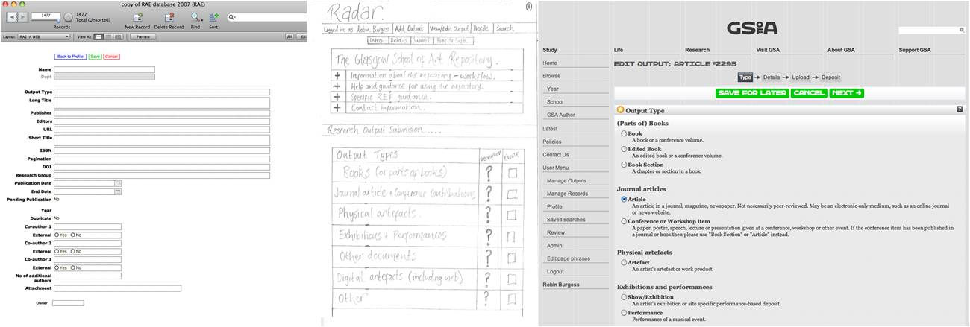
Figure 1: The stages of development for RADAR. Image 1 shows the filemaker database. Image 2 illustrates sketches and designs for the new repository. Image 3 is one page from the new repository, embedded within the new GSA website.

The project had various objectives from the onset.
- The purpose is to have a more user friendly research repository that is engaging for internal and external users
- Enhance the interoperability of the repository through engagement with EPrints a renowned repository development company
- To embed our current research database into the newly designed interface via interaction with Eprints
- Achieve a greater user experience, and make using the repository enjoyable
- Enhance the links of the repository with likeminded institutes
- Enhance functionality and reporting capabilities
- Improvements made to the REF process and recording of research outputs, making this process smoother for researchers and administrators.

From these objectives the following outcomes were produced – table 1.

Table 1: Outcomes from this project
Output/Outcome Type | Brief Description
An improved front-end repository interface | This has been achieved through interaction with ScreenMedia who helped develop the new GSA website. They were therefore involved in integrating the repository into the website where it can now be accessed easily, internally and externally. The repository interface has been set up so that it complies with GSA branding guidelines and fits with the design of the website, making it much more embedded within the infrastructure at GSA.
An improved back-end interface | By working with EPrints the back-end of the repository has been enhanced and improved. The structure set out by EPrints repositories is simple to follow and utilise. It helps to enable academic, managerial and research staff to search and analyse research outputs, edit and update repository information, create and deposit new items – in various formats (textual and non-textual).
Improved support for non-text items in the repository | RADAR has the ability to handle non-text items such as drawings, designs, photographs, audio and video files. This capability has been acquired through the work that the Kultivate Group did with EPrints. Documents, images and files can be uploaded into the repository and subsequently viewed, ensuring there is proper copyright control in place.
Connection and buy-in from users | This is related to advocacy and training staff. This is very much a continual process, and is very much linked to the REF process
An enhanced system based on usability, design, aesthetics and user needs | Through interaction with EPrints and ScreenMedia RADAR has been produced. It is a much more user friendly system that has adapted EPrints tried and tested repository methodologies. The design of the system has adhered to GSA guidelines and fits nicely with the new GSA website that was produced and designed by ScreenMedia.
Greater interoperability with other research repositories across the UK | During the project GSA has become much more involved in the repository work being carried out at other institutes. This was aided by GSAs research information manager becoming part of the Kultivate group. This group held regular meeting where discussions were held in relation to repository development, enhancement and methodologies.

Within a project like this, focus needs to be given over to the beneficiaries of the repository. In the case of the work being undertaken at GSA, various user groups were targeted and investigated. With regard to project outcomes, these can be split into internal and external groups who will benefit from this project – the development of RADAR.

Internal
- Students will benefit though access to an enhanced interface, enabling access to world-leading research in the creative arts, design and architecture, that supports linkages between research, knowledge exchange and the student learning experience.
- Academic Staff will benefit from an enhanced bespoke interface designed according to the requirements and culture of a visually-based research environment. The new system is an exciting tool for researchers in visual disciplines to deposit and disseminate their research production, assisting them to address key agendas and objectives in terms of public engagement, impact and demonstrating the value of creative art and design research.
- Support Staff, including research developers and the learning resources team, will benefit from a more up-to-date and extensively populated repository, resulting from increased take-up.
- Repository manager/administrator has learnt how to integrate EPrints with institutional systems
- Managerial staff will benefit from this important system enhancement through the resulting changes in culture, practice and professional research capacity amongst the research community

External
- Academics, students, researchers and practitioners across the creative arts, will gain access to a more diverse range of world-leading research outputs generated through GSA.
- Research assessors (e.g. funding bodies, peer reviewers) will benefit from improved access to the range of research outputs from GSA, including opportunities to view non-textual items and artefacts.
- The repository community will gain insights into the integration of EPrints interfaces with non-standard repository systems and the integration of a comprehensive range of rich and varied research outputs – taking the repository beyond text-based items.

The following table gives comments related to the types of impact that the development of RADAR has seen so far.

Table 2: Impact areas from this project
Impact Area | Comment
Improved depositing of research outputs by academic staff | RADAR has provided research staff with an improved repository based on the interface and functionality (ease of use) for depositing research outputs.
Greater sharing of information between schools present at GSA | RADAR is viewable by all staff on the GSA website, therefore information that is stored in the repository can be searched and viewed by other staff members.
Improved collaborative research and knowledge exchange | GSA have improved their links with other institutes (particularly arts institutes) to aid in the exchange of knowledge and best practices for the development and utilisation of repositories. A particular example has been their involvement in the Kultivate group that came about from the Kultur project. Plus GSA have developed better links with the DCC at Glasgow University which has had an impact on helping GSA to understand data management methods more.
Impact on the approach to REF | RADAR will help to make the REF process run smoothly and will hopefully reduce the administrative burden placed on the research staff and department.
Record keeping of research outputs | It is envisaged that part of activity planning for staff will involve that they regularly maintain their records within the new repository.
Alignment of GSA with other institutes with regard to research repositories | GSA engaged with EPrints for the development of their repository. Many other institutes have EPrints repositories, therefore it can be said that GSA have become part of the ‘EPrints community’ and will be able to share good/bad practice with others and learn from others. This alignment enables greater interoperability for GSA, and can help to enhance links with other institutes for research opportunities.
Enhanced knowledge of digital data management | This has been aided by liaison with the DCC and networking with other repository managers/developers/administrators.

The real difference that the project has brought to GSA is an improved research repository that is fully integrated within the school through web technology, and has greater functionality and usability compared to the previous filemaker database system. A key impact is that the repository can be accessed by staff when they are away from the office, for example working from home. This has helped to improve the embedding and use of the repository by staff. Many staff members at GSA are part time and with other work commitments do not always have time to update their research profiles when in the office, therefore being able to access RADAR from home helps eliminate this issue.

The wider community has benefited from our involvement in this JISC funded project as it has raised awareness amongst other institutes towards GSA interests in repositories and has helped GSA to become more in line with other arts institutes for the management of research outputs. The wider community will be able to access information about the research that is taking place at GSA and gain knowledge of the capabilities of research staff at GSA through RADAR and the new GSA website. RADAR will also help GSA to showcase the research that is taking place to a greater extent which will hopefully aid in attracting students to the school.

With regard to changing stakeholders attitudes, it is hoped that this project has highlighted to them the importance of management of their research outputs and the utilisation of the research repository. Their engagement with the repository will ultimately benefit them when it comes to the REF. Plus it can be seen as a tool for improving their profile within the school and the arts research community.

The development of RADAR is continuing. The first iteration of the system is being utilised by research staff at GSA, and the processes associated with using an EPrints based repository are being employed, with regard to reviewing and editing research outputs. The main purpose and direction for the utilisation of RADAR has been for REF, and the mock REF process that GSA are currently undertaking. The research repository will form the basis for staff to submit research outputs for consideration within the REF. As the system develops it will be integrated with other systems at GSA, particularly those related to learning services and the library.

As RADAR develops further and comes to completion GSA will adopt the advocacy strategies set out by the Advocacy Toolkit that was developed as part of the Kultivate project. This is a tried and tested approach for helping take-up of repositories within institutes. GSA will also explore ways in which the repository and the capabilities of EPrints can be integrated within other data management systems employed by the school, such as those seen within the library and Information Services.

