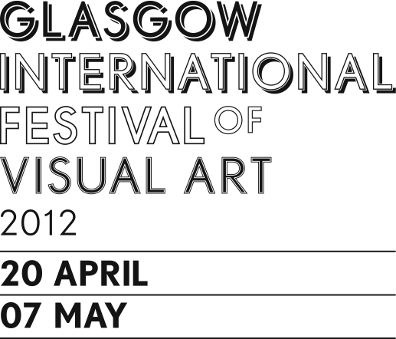*Back to the Things Themselves*

Lesley Punton & Judy Spark

The Briggait: 141 Bridgegate, Glasgow,

Presented as part of Glasgow International Festival of Visual Art, 2012

Lesley Punton and Judy Spark share a concern in their attempts to bridge a certain sort of gap; that of the difference between the physical experience of specific varieties of ‘natural’ phenomena or places, and their articulation in human terms. Both feel the impossibility attached to this problem, but nonetheless remain dedicated to its resolution through the making of art. For these two artists, the making of an artwork is a process of interrogating lived experience and it is the language used to express this search, which is also a quest for other varieties of understanding, alternative ways of knowing the world. The question of whether such alternative interpretations are subjective or in some way universal is inherent to the work.

The processes of Punton and Spark sustain common patterns; periods of concentrated engagement with objects and places of interest, an awareness during such engagement, of duration, of breathing, of scale, and working methods which mirror these physical experiences; an almost meditative approach to drawing for example. The results stand as evidence of the inquiry, the process itself is what is important. The bodily experience of phenomena is reflected in the consideration of how, and for how long, the viewer physically encounters the work, which is ‘quiet’ and aims to draw the viewer into a contemplative ‘space’ in which they might imagine, or consider, their own process of engagement with ‘the things themselves.’

Having recognised the similarities between their working practices, the two artists have become begun to pay close attention to their contrasting approaches to the pursuit of an idea; Punton’s is deeply experiential, entirely dependent upon the measured contact of her feet with the ground of the remote environments she craves. Spark however, despite a natural bent towards phenomenological thinking and certain Eastern approaches to the natural world, feels unable to completely suspend her embeddedness within technologically bound western culture, for her a revised understanding of one, can only impact the other.

From the dialogue generated by these commonalities of practice, as well as their disjuncture, the artists intend to probe the gaps between experience, whether natural or technological, and its articulation, with the hope of uncovering the fertile ground of potential new understandings. The resulting work takes the form of drawings, photography and recorded sound.

[*http://www.lesleypunton.com/*](http://www.lesleypunton.com/)[*http://lesleypunton.blogspot.co.uk/*](http://lesleypunton.blogspot.co.uk/)

[*www.judyspark.co.uk*](http://www.judyspark.co.uk)[*http://www2.rgu.ac.uk/subj/ats/research/staff/spark.html*](http://www2.rgu.ac.uk/subj/ats/research/staff/spark.html)

Taking place every other year, and combining some of the characteristics of a conventional arts ‘biennial’ with a more event-based experience, Glasgow International Festival of Visual Art is a unique event in the international calendar with one of the most groundbreaking and dynamic presentations of contemporary visual arts practice. GI is a unique event that offers both globally recognised and emerging Glasgow-based artists across the spectrum of the city’s art scene a platform to show new work to both national and international audiences while also introducing the work of important international artists. Since its inception in 2005 the Festival has brought together the key organisations in Glasgow’s diverse artistic community, presenting unique events and special commissions rooted in the achievements of the local artistic community, while drawing on important international developments in contemporary art.

*Judy Spark would like to thank:* Anne Campbell, Jim Hamlyn, Callum Kellie, Malcolm McKie, David Palmer, Lesley Punton, Helen Smith, Kirsty Stansfield, Eileen and James Spark, Shirley Tipping, Allan Watson and Simon Yuill.

*Lesley Punton would like to thank:* Jim Hamlyn, Angus Hamlyn, Emilia Muller Ginorio, Theresa Moerman Ib, Tor Jonsson, John Foot, Kasia Zych, Judy Spark, and my colleagues and the students at the Glasgow School of Art.