THE GEOMETRIC POETRY OF GRAPHIC ART
Glasgow School of Art was founded in 1845 as one of the Government Schools of Design under the control of the Department of Science and Art in South Kensington. To current eyes this might look like an awkward entanglement of artistic and non-artistic cultures, because the past values of this era are veiled from us. We are the inheritors of at least a century of polemics about the aims of art and design education that have poured scorn on the methods and aims of these early art schools. At the end of the nineteenth century education reformers inaugurated dramatic changes in the direction in art and design education, inspired in part by the philosophies of anti-industrial campaigners such as John Ruskin. As a result, later commentaries on the history of art and design education have frequently dismissed four decades of activity under the control of the Department of Science and Art as a faintly ludicrous episode dominated by a power-crazed Henry Cole (Frayling 1987: 132-3). This collective blindness does a disservice to the students, artists, designers and teachers of this period. In this article I want to indicate the attraction of the ‘machine dreams’ (Sussman 2000: 197-204) contained in geometrical and mechanical drawing discourses in the second half of the nineteenth century with relation to the realities of working in the local visual economy in Glasgow.

The main enemies of creative art and design, in the eyes of critics such as Ruskin, were Henry Cole, the civil servant who organized the national curriculum of the Government Schools of Design, and William Dyce, author of The drawing book of the Government school of design (1843). Dyce’s Drawing book was intended to ‘educate young persons in the art of inventing’ and also to act as a resource book of ‘manufacturers and pattern-draughtsmen’. Students began their course through graded exercises in geometrical drawing with ruler and compass. For example in Exercise I the student executed parallel straight lines, which were then divided into halves, quarters, thirds and fifths. Exercise V began with triangles that were used to build composite forms, once again constructed with ruler and compass. In contrast to design motifs based on observation of nature, this abstract approach uses simple reiterations of geometrical drawing techniques, more closely allied to the visual world of engineering.

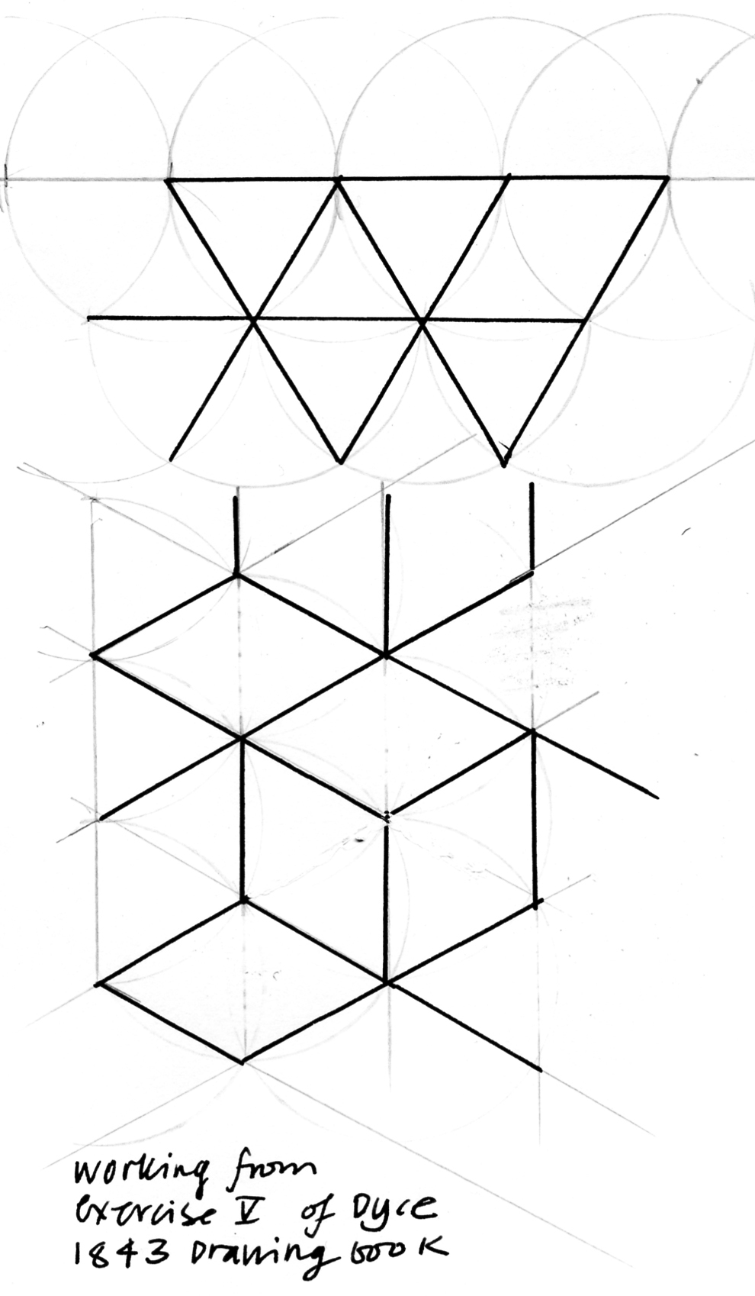 [Insert Drouth 1 image near here]

These linear and geometrical techniques of drawing came under attack from critics almost immediately. To Ruskin, these linear styles denoted servitude and the horrors of industrialization. The act of drawing had a central role in Ruskin’s vision, for to him drawing was not simply a functional aid in working life, but was a fundamental technique for personal and creative development. At issue were questions such as who could be allowed to develop and demonstrate skill, and who could contribute to public speech. In his wholesale rejection of industrial working, Ruskin set up a misleadingly simple opposition between the ‘artistic’ judgment of the creative craftsman, and the ‘technical’ functionalism of the industrialist. Nevertheless, Ruskin’s doctrines, imbibed unconsciously from the new art school ethos he instigated, still resound in many contemporary accounts of geometrical drawing for design in the nineteenth century, so Dyce’s drawing exercises have been attacked, frequently, as a weapon for indoctrinating workers into an ideology of industrialization.

David Brett has argued that abstract geometrical forms were held to be empty of cultural symbolism and were intended to wipe out the past. As technical and design drawing came to be established as the first stage of industrial production, then factory owners set out to train workers to accept this kind of visual language, and to look for nothing further. To critics, the Government Schools of Design were part of a conspiratorial programme to expand education to the masses in the service of industrial production and ‘science-based technology’. Thus teaching drawing through geometrical and linear styles, perceived by their advocates as ahistorical, would break down worker resistance to change through the ‘destruction of age-old habits of thought and behaviour’ (Brett 1987). Step-by-step laborious drawing instruction, it is claimed, imparted docility and an industrial vision through the physical imposition of a system; the notion of ‘doing the right things in the right place’ (Denis 1995: 71; Purbrick 1998).

These arguments are familiar, but they are not completely convincing, as we are asked to believe in shadowy but all-powerful forces coercing passive workers, where the activity ‘drawing’ is given an agency denied to its hapless minions. The analysis is too simplified and too polarized; most importantly it leaves out the thoughts and experiences of the people who did the drawings and the ways in which they used their pictorial skills to try to gain status amongst various social groups. In fact, many factory workers deliberately sought out drawing classes in their spare time to advance their ambitions to become designers or industrial draughtsmen (Schmeichen 1995). Additionally, even if bosses did aim to control the factory floor through drawing, the supposed control center (the drawing or design office) was a gathering of educated ambitious employees whose aims both individually and collectively were to a great extent uncontrollable. Finally, the characterization of geometrical drawing as lacking in cultural resonance, or in creative satisfaction, is not accurate.

Geometrical drawing was not a new-fangled modern development. Instead, it is one of the oldest continuous strands of formal education in the West. Let’s recall a bit of geometrical thinking still familiar, albeit as a distant memory to most readers, from their first years of serious schooling, Proposition I from Euclid’s Elements of Geometry; ‘Problem: to describe an equilateral triangle upon a given finite straight line’.
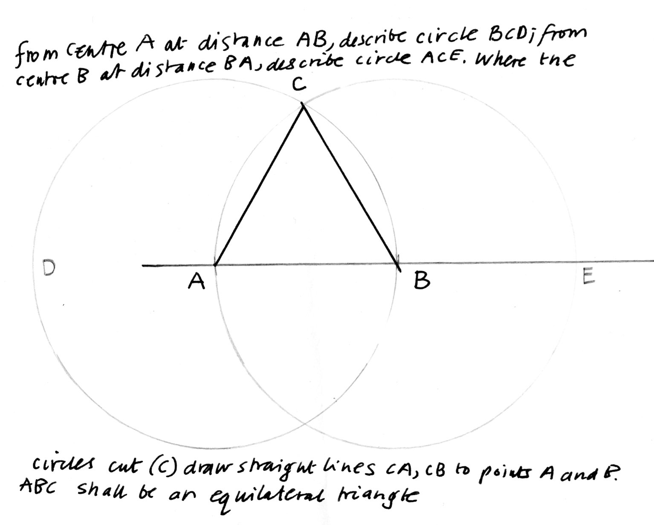[Insert DROUTH 2 image near here]

Euclid was a mathematician active around 300BCE in the classical Greek world. For this article, I referred to my nineteenth century edition of the Elements (Playfair 1804), a version that would have been familiar to every schoolchild, apprentice or aspiring designer in Scotland throughout the nineteenth century. The Elements were respected for their historical connection to generations of scholars even while this thinking became ‘naturalised’ through use. Everyone starting their education worked through Euclid’s axioms and exercises in geometrical proof, so by the time they were grown up these ‘mathematical visions’, were ingrained, and seen as ‘fundamental properties of spatial reality’ (Richards 1988: 1; 187). Nevertheless, the fact that the Elements were a part of the revered classical Greek world was also important, so that the activity of thinking through geometrical drawing was often invested with a halo of much wider cultural significance.

If current images of the art student seem far away from this discussion of workers and factories, however, this was not the case in relation to the Schools of Design. Many students in the first decades of the school came in the evening after finishing work, at a period when Glasgow was developing into one of the largest industrial and engineering centers of Britain, exporting to markets across the Empire. By the 1840s, Glasgow workers were accustomed to seeking out education in drawing. The city is one of the key locations for the start of the Mechanics’ Institute movement, with initiatives such as the establishment of Anderson’s Institution in 1796 and Glasgow Mechanics’ Institution in 1823, founded before the London Mechanics’ Institution in 1824. By 1834, classes in mechanical and architectural drawing were in progress, and the institution was in correspondence with other worker organizations about staging national exhibitions that included not only industrial items such as technical drawings, apparatus, models, or carpentry, but also sculpture, painting, drawing and engraving. If we consult printed sources such as the Mechanics’ magazine (founded in 1823), the articles and letter pages suggest that industrial workers were not cowed by learning geometrical or mechanical drawing, but rather the reverse for the tone of reader contributions show that learning and displaying drawing skills could be a vehicle for combative and playful self-assertion. In Glasgow, by July 1856 the Mechanics’ Institution was busy hiring two separate drawing teachers in order to offer classes not only in mechanical and architectural drawing, but also in painting and perspective. Drawing classes in both mechanical and ornamental mode at the mechanics’ institute expanded, even with the competition from the newly founded Government School of Design in Glasgow after 1845 (Fairfull-Smith 1999; Rawson 1999; Robertson 2011). Indeed, the Government School of Design offered very similar tuition, and it appealed to similar constituencies of workers. For example in 1847 the Government School of Design in Glasgow reported student trades and occupations that included workers such as masons, tradesmen from the decorative arts such as gilders, plasterers and pattern makers, print trade workers, engineers and architects, as well as 49 warehousemen, 72 clerks and 105 unspecified ‘schoolboys’. Students both in the Mechanics’ Institution and in the Glasgow Government School of Design came largely came from a background of skilled manual work, manufacturing, trade, or commercial office work. While it was certainly true that former students from either school sought work as draughtsmen or chief foremen in engineering works after signing up for drawing classes, these artisans and lower middle class workers also applied themselves to the study of decorative, architectural and fine art modes of drawing, in order to get work in various local manufacturing industries that produced machine-made ornamental items such as textiles, furniture or carpets, as well as in more ostensibly artistic occupations such as illustration, sculpture and painting.

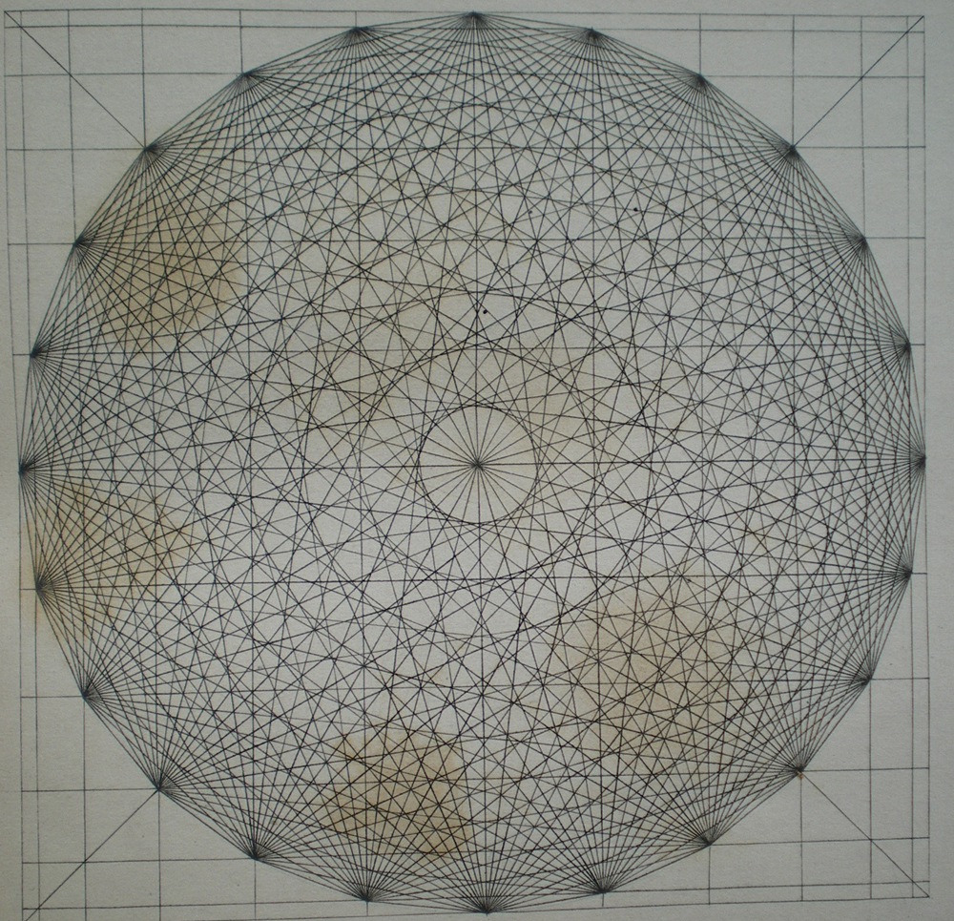 [Insert DROUTH 3 image near here]

The library holdings of Glasgow School of Art allow us to see some of the working of this local world where art, design and manufacturing interpenetrated. For example, the volume One thousand and one initial letters designed and illuminated by Owen Jones (1864) was donated from the working library of Macfarlane and Smith, Painters and Decorators, Sauchiehall St., while Proportion, or the geometric principle of beauty, analysed (1843) by David Ramsay Hay, was gifted to GSA from the library of John T. Walker, a Glasgow designer. In this book, we see the full ramifications of the cult of Euclid, and of geometrical drawing. Hay developed geometric rules of visual beauty from Greek theories of harmony in music, dividing up his pictorial field in the same proportions and divisions that give rise to harmonies of octaves, fifths, and thirds in sound (as 1:2; 2:3; 4:5, and so on). In other published works that he also refers to in this volume, Hay had elaborated at more length connections between simple geometric figures such as the triangle, square and circle, and the primary colours of blue, red and yellow, ideas that are more normally associated with modernist writers such as Kandinsky. But in Proportion, Hay was most concerned with linear and geometric patterning. He achieved this by superimposing squares and circles, then divided these harmoniously according to his rules of proportion, finally he set about combining and multiplying permutations of connections between the points on his diagrams. In the process, complex but controlled abstract patterns were generated. These patterns are similar to those generated by the Moorish decorators and architects of great palaces or mosques such as the Alhambra. Owen Jones first established his reputation as an authority on Moorish decorative building through the elaborate; lavishly illustrated publication Plans, sections, elevations and details of the Alhambra (1836-45) that helped to develop the Victorian taste for elaborate patterning and Moorish designs. But although Hay used similar geometric procedures, driven by similar mystic ideas of cosmic order that inspired Muslim designers, he makes no mention of the traditions of Islam. Instead, Hay emphasized his direct contact with the world and philosophy of the ancient Greeks that in his mind was achieved through engaging in geometric drawing. To Hay, these repetitive subtly varying patterns revealed the underlying richness of the cosmos: ‘Forms and figures as used in the arts require one or other of two qualities to render them pleasing: the first is the imitation of natural objects, the second harmony, produced by the proportion and arrangement of the elements of abstract form. The one is like a simple description in plain language, the other is the geometric poetry of graphic art’ (Hay 1843: 58).

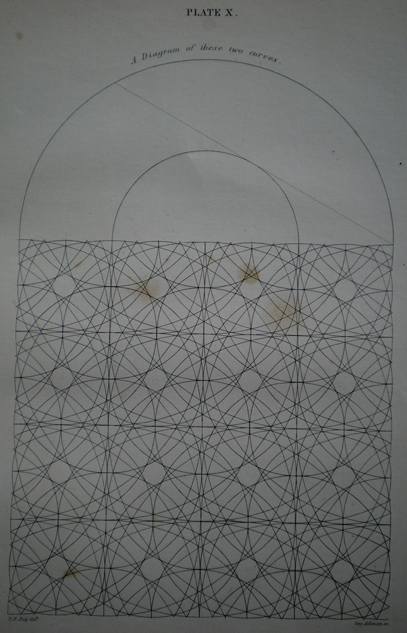 [Insert DROUTH 4 image near here]

Aspiring artisans were motivated to learn geometrical drawing as it could be used to design many things, from machined forms, actual tools and mechanisms, to the elaboration and ordering of surface decoration. It was a valuable skill in the labour market. But as well as these apparently pragmatic and ‘commercial’ reasons for learning to draw, these techniques did allow students and workers to explore the manipulation of abstract relationships and take creative ownership of their drawing tasks. Of course, the Government Schools of Design did not have this in mind, their aims were more narrowly framed towards the creation of useful workers, and this was made very clear to students.
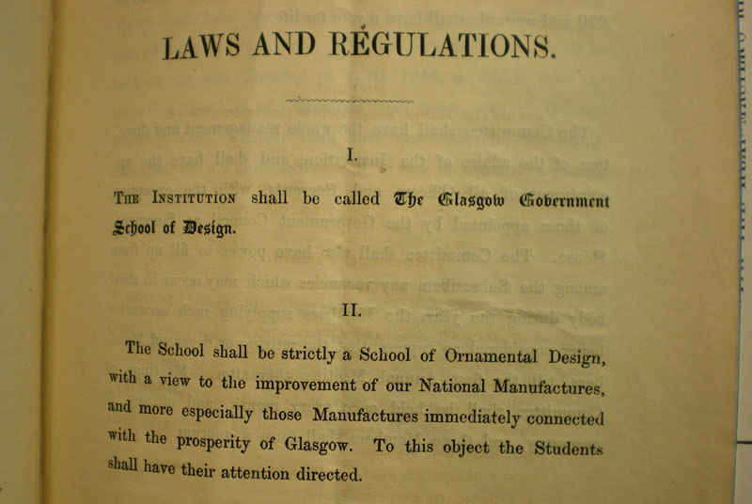[Insert DROUTH 5 image near here]

As we know, campaigners such as Ruskin set out to challenge these hierarchies, to include workers in a more equal and creative society. But at the same time, a growing market for contemporary fine art from 1850 onwards, and the corresponding power of artists, exhibitors and critics also worked to create a discourse that excluded Cole’s version of ‘practical art’ from art and aesthetics (Wolff and Seed 1988; Prettejohn 2005: 111-173). By the early twentieth century, these new attitudes had become so entrenched that when the conceptual artist and dada nihilist Marcel Duchamp used mechanical line drawing in his construction the Large Glass of 1923 to represent the nadir of art (Nesbit 1991: 372), his playful conceit was used in part to reflect the firm and unreflecting currency of that assumption. Ruskin feared, wrongly, that geometrical drawing would drive out the creativity of working class artists and designers; instead, the new doctrines of free creative drawing, derived from Ruskin, were used to drive out workers from the class of artists and designers, even in histories that are sympathetic to their cause.

REFERENCES
Brett, D. (1987) ‘Drawing and the ideology of industrialization’ Design Issues III (2), pp. 59-72
Brett, David (1992) On decoration Cambridge: Lutterworth Press
Denis, Rafael Cardoso (1995) The educated eye and the industrial hand: art and design instruction for the working classes in mid-Victorian Britain Unpublished PhD Dissertation, Coutauld Institute of Art, London
Fairfull-Smith, George (1999) ‘Art and design education in Glasgow in the 18th and 19th centuries’ Journal of the Scottish society for art history 4: 9-16
Frayling, Christopher (1987) ‘The strange case of the Duke of Wellington’s funeral car’ in Walker, Derek, ed. The great engineers: the art of British engineers 1837-1987 London: Academy Editions
Hay, D.R. (1843) Proportion, or the geometric principle of beauty, analysed Edinburgh: William Blackwood and Sons
Jones, Owen (1864) One thousand and one initial letters designed and illuminated by Owen Jones London: Day & Sons
Macdonald, S. (1970) The history and philosophy of art education London: University of London Press
Nesbit, Molly (1991) ‘The language of industry’ in Thierry de Duve, ed The definitively unfinished Marcel Duchamp Halifax, Nova Scotia and Cambridge, Mass.: Nova Scotia College of Art and Design and MIT Press
Playfair, John (1804) Elements of geometry; containing the first six books of Euclid Edinburgh: Bell & Bradfute
Prettejohn, Elizabeth (2005) Beauty & art 1750-2000 Oxford: Oxford University Press
Purbrick, L. (1998) ‘Ideologically technical: illustration, automation and spinning cotton around the middle of the nineteenth century’ Journal of design history 11: 275-93
Rawson, George (1999) ‘The Glasgow Government School of Design, 1845-53’ Journal of the Scottish society for art history 4: 18-25
Richards, Joan L. (1988) Mathematical visions: the pursuit of geometry in Victorian England San Diego: Academic Press
Robertson, Frances (2011) Ruling the line: learning to draw in the first age of mechanical reproduction Unpublished PhD Dissertation, Glasgow School of Art
Schmeichen, James A. (1995) ‘Reconsidering the factory, art-labor, and the schools of design in nineteenth-century Britain’ in Denis P. Doordan Design history: an anthology Cambridge, Mass.: MIT Press: 167-77
Wolff, Janet and John Seed, eds (1988) The culture of capital: art, power and the nineteenth-century middle class Manchester: Manchester University Press: 45-81
University of Strathclyde, Archives of Glasgow Mechanics’ Institution, letter file incoming OC/11/1/100

