THIS HILL IS DANGEROUS
Illustrations.

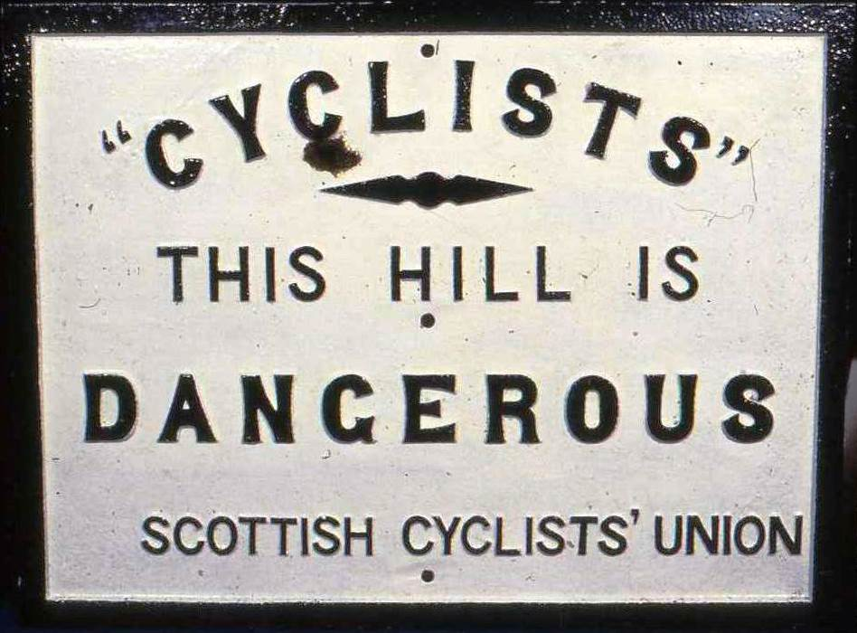

1: Danger Board, Scottish Cyclist’s Union, first half of 1880s. Cast iron. 22 x 30 inches.

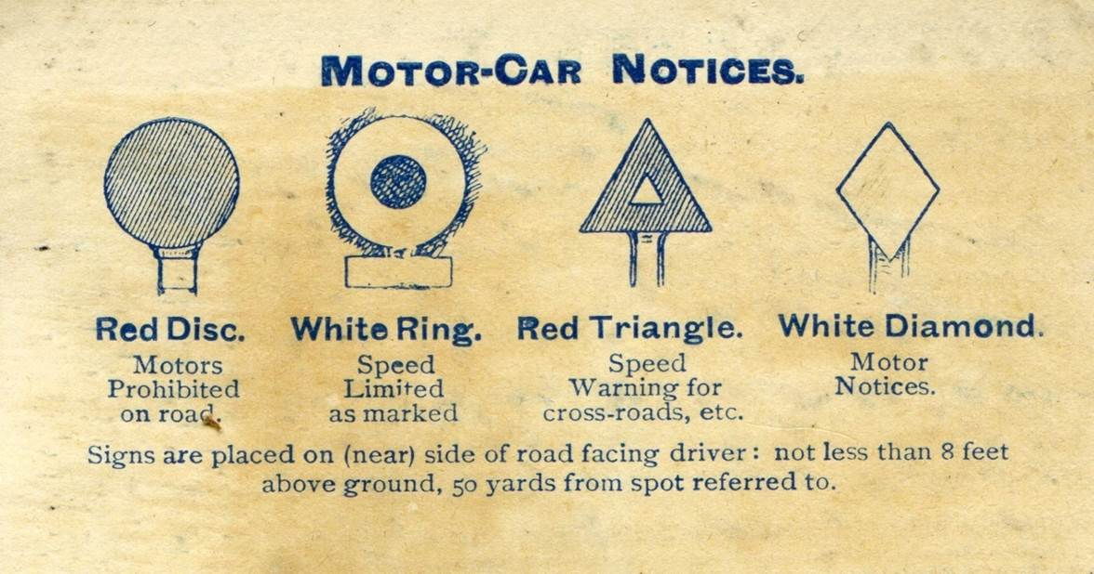

2: The four ‘Motor-Car Notices’ specified by the 1903 Motor-Car Act and introduced by The Local Government Board in 1904. The Speed Warning Triangle had blades of 18 x 3.5 inches. From Inglis H.R.G. The Contour Road Book of Scotland. Edinburgh: Gall & Inglis, 1913, Foreword.

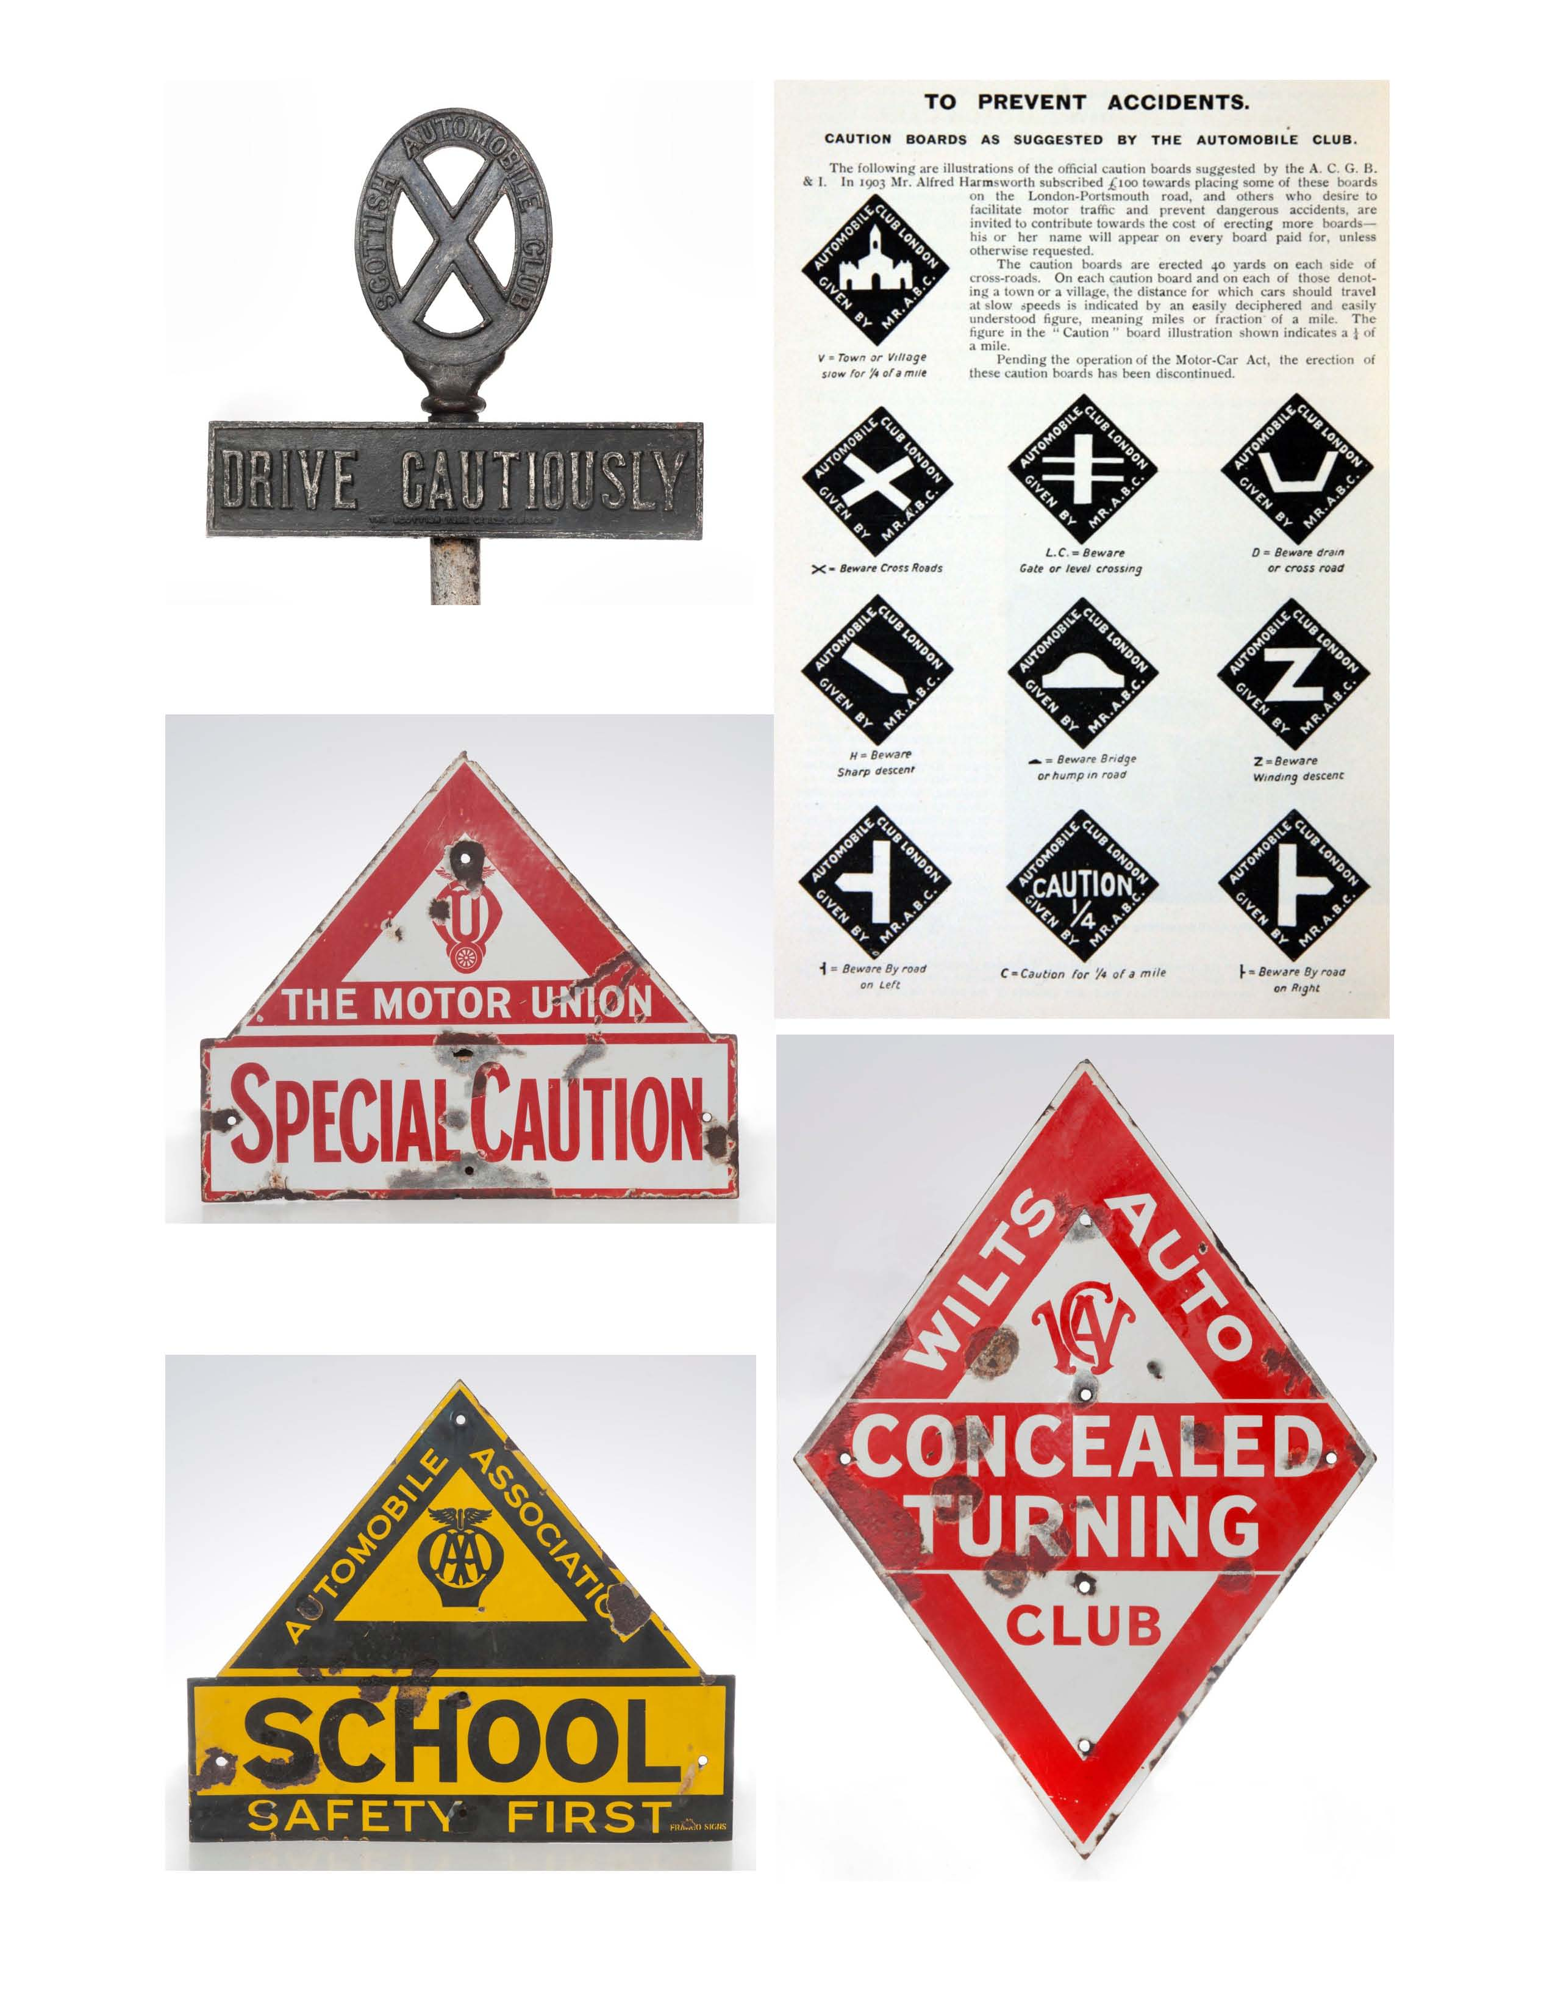

3: Composite picture of Club signage: Clockwise from top left:
Scottish Automobile Club, DRIVE CAUTIOUSLY, c1905 (Scottish Tube Co, Glasgow), cast iron, 14.5 x 9.5 and 4.5 x 24 inches.
Specification for 1902 AC signs from Motoring Annual and Motorist’s Year Book, 286.
Wilts Automobile Club, CONCEALED TURNING, c 1905, vitreous enamel, 30 x 26 inches. Motor Union, SPECIAL CAUTION, c1906, vitreous enamel, 22 x 26 inches .
AA, SCHOOL, c1925 (Franco Signs, London), vitreous Enamel, 22 x 26 inches.

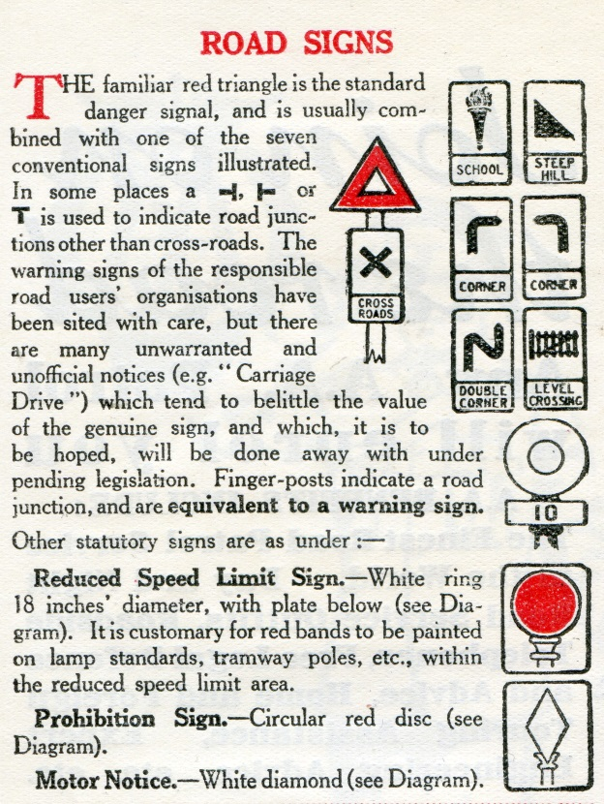

4: 1921 National Signs illustrated in “Safety First” on the Road, London: National “Safety First” Association, 1929, 18, alongside the remaining three 1904 Motor-Car Notices.
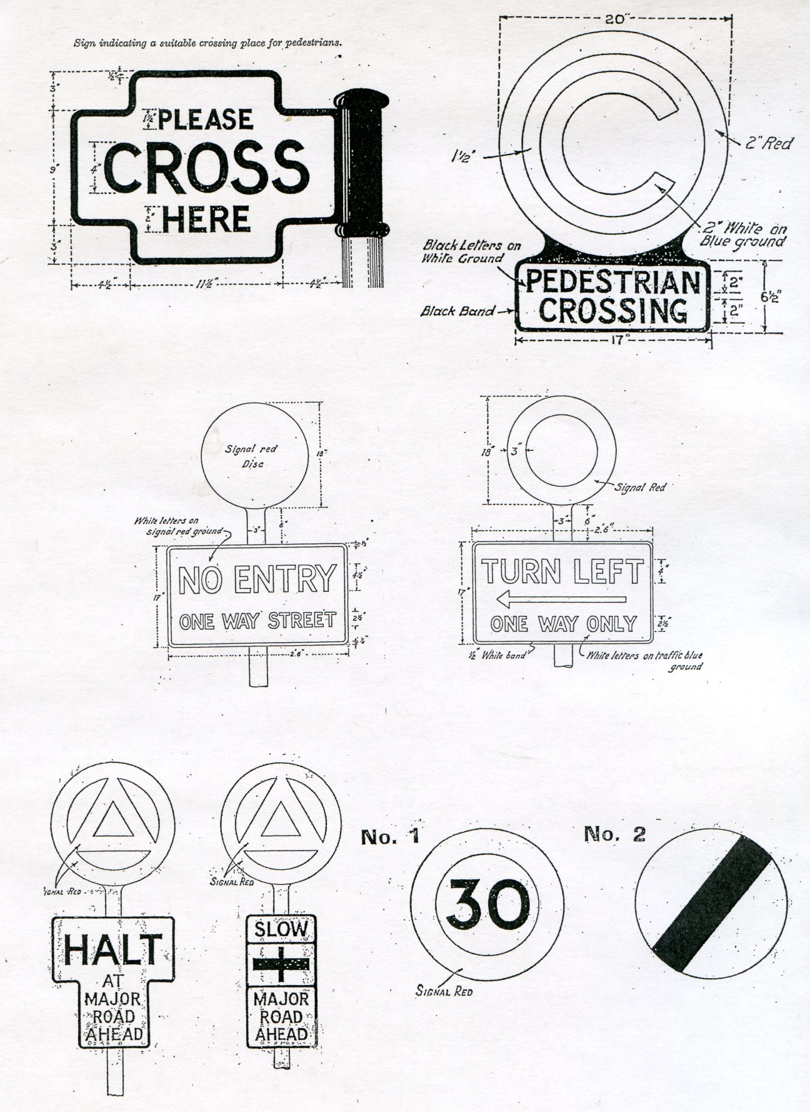
5: Traffic Signs specifications from 1933, 34 and 35 Regulations
Top: 1927-34 and 1934 pedestrian crossing signs
Middle: 1933+ prohibition and order signs
Bottom Left: 1935+ HALT and 1933+ SLOW order-with-warning signs
Bottom Right: 1935+ speed limit and end of speed limit signs.
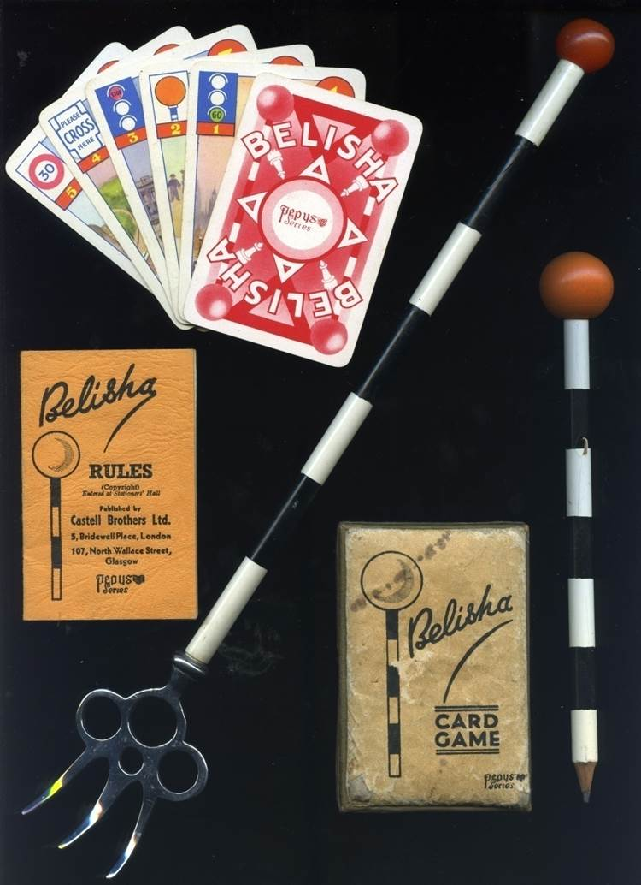
6 Belisha Beacon paraphernalia c1935
Left: Pepys ‘Belisha’ card game
Right: Wooden Pencil
Centre: Celluloid and Urea toasting fork handle
Private Collection
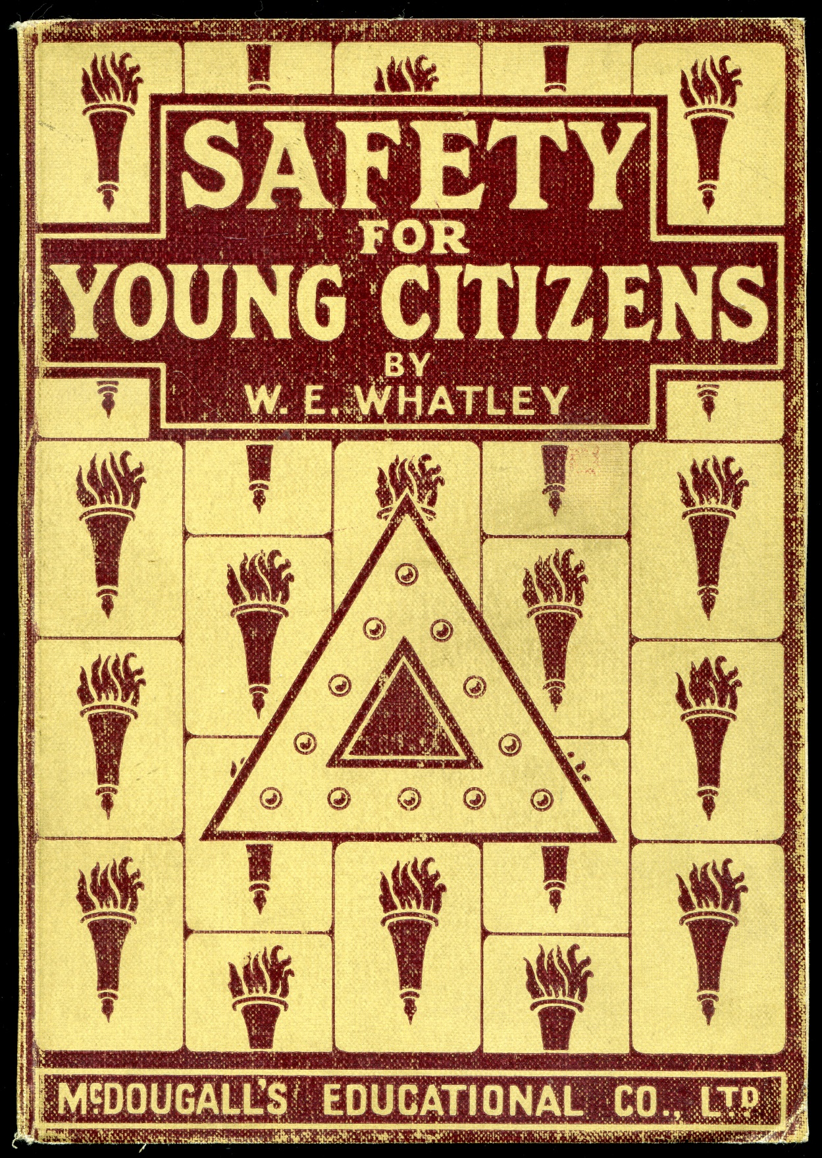

7 Cover for Whatley, W. E. Safety for Young Citizens. London: McDougall, n.d. (c1937). Although on general safety the cover is a pavement of ‘SCHOOL’ torch pictograms overlaid with a ‘reflectorised’ ‘Danger’ triangle.

